**JVM Architecture**

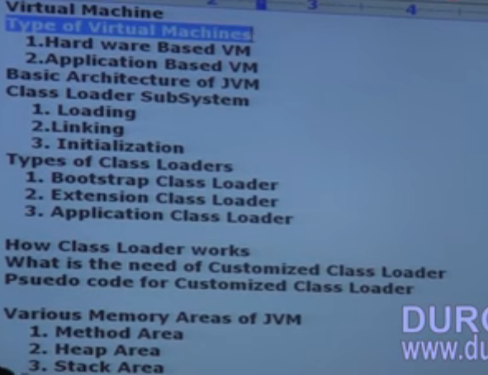

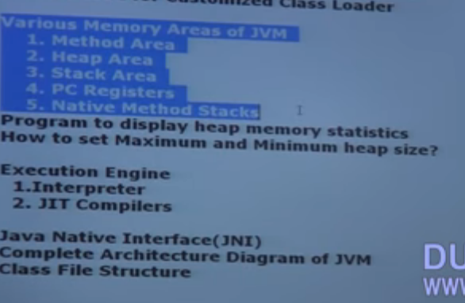

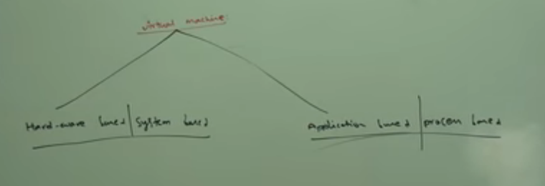

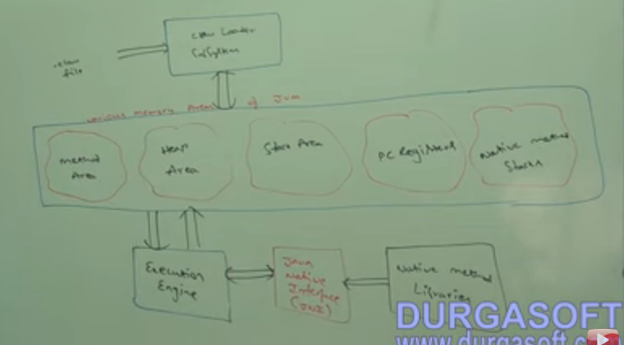

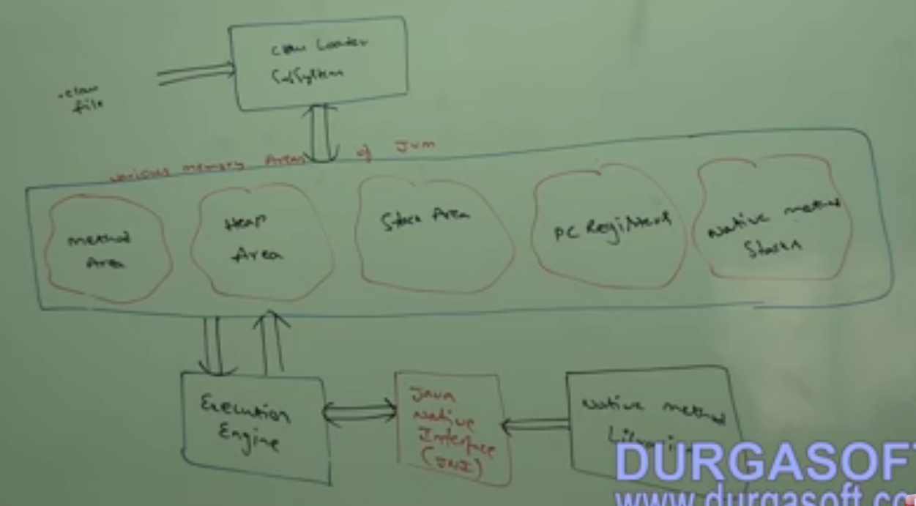

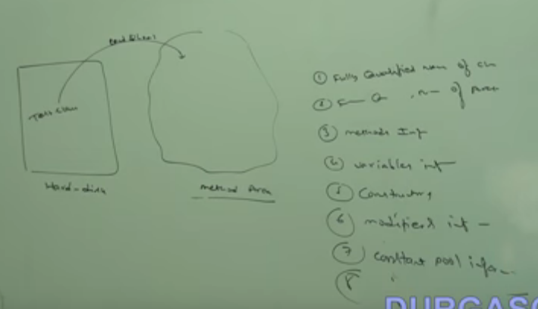

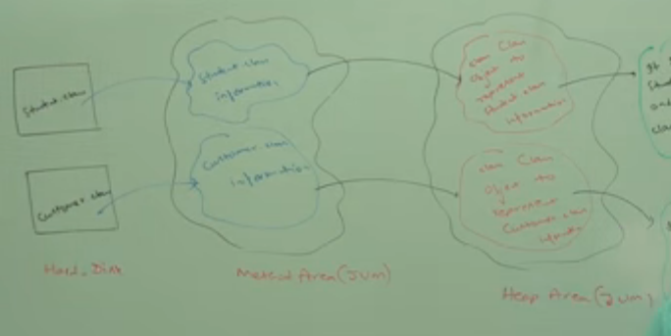

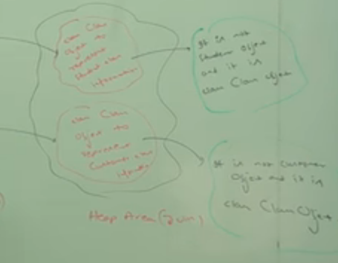

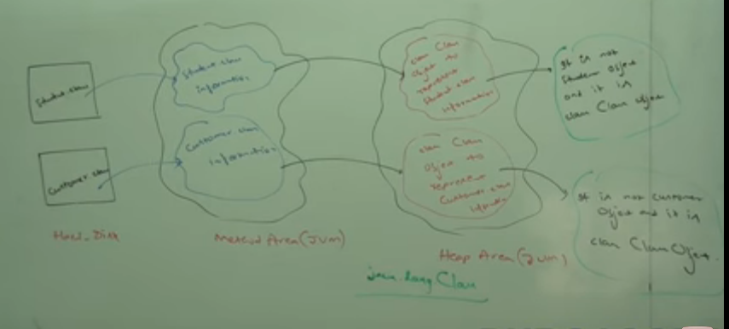

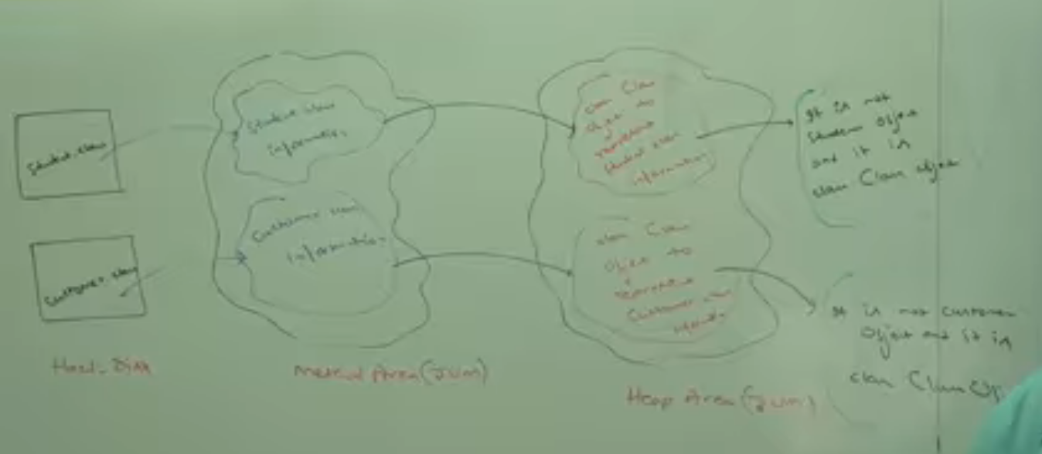

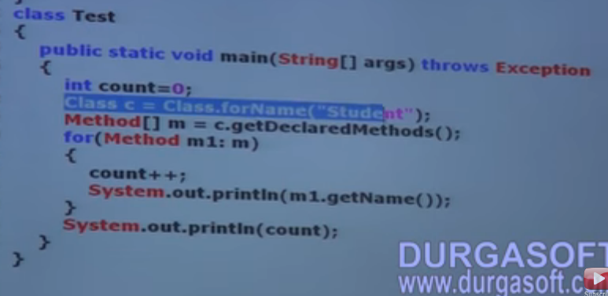

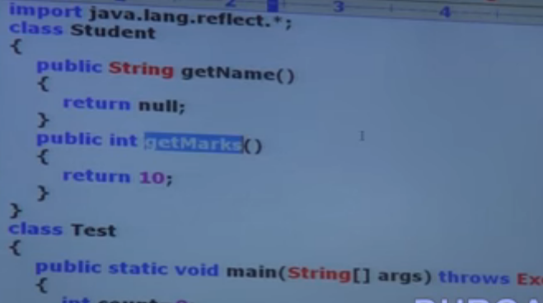

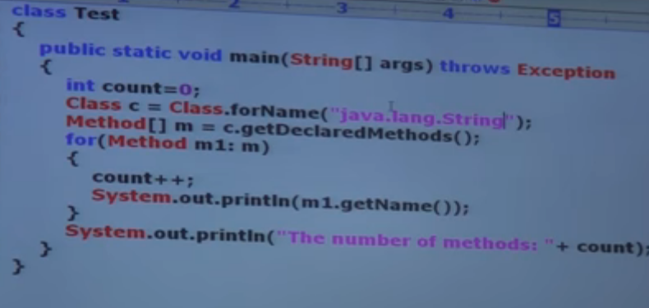

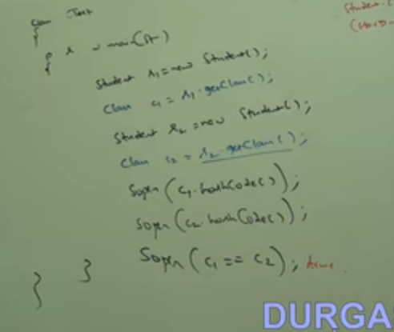

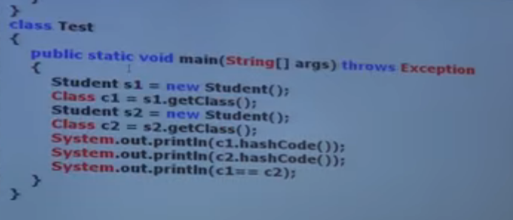

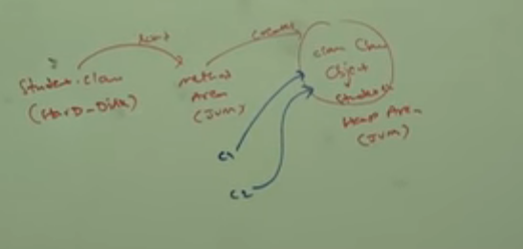

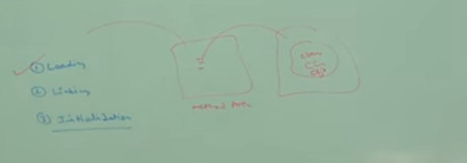



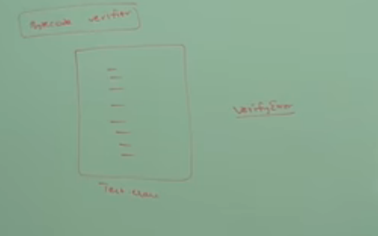



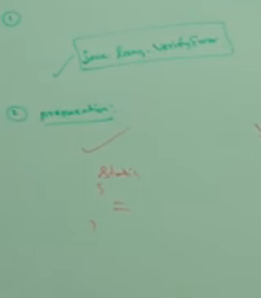

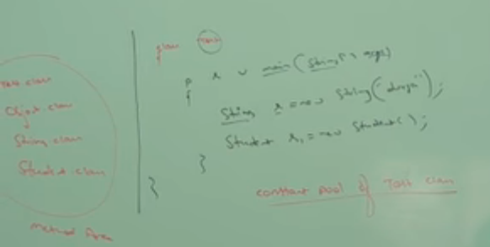



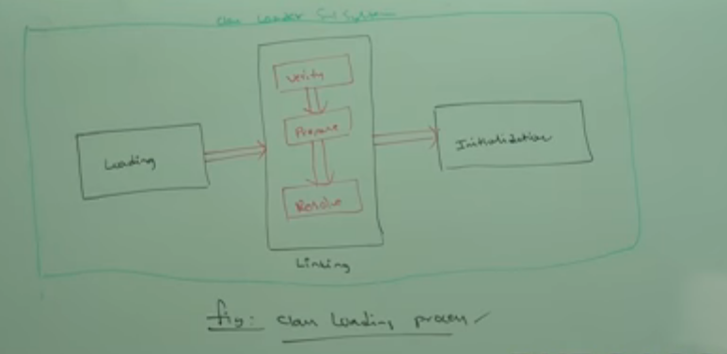

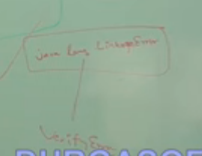

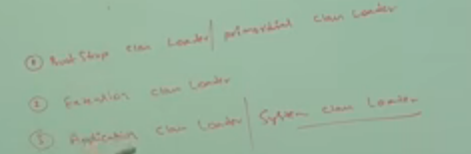

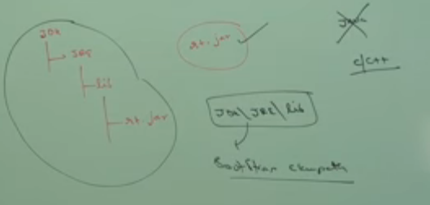

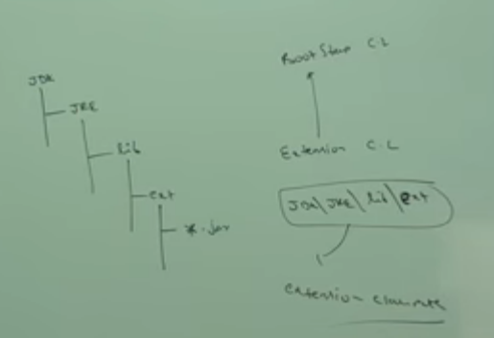

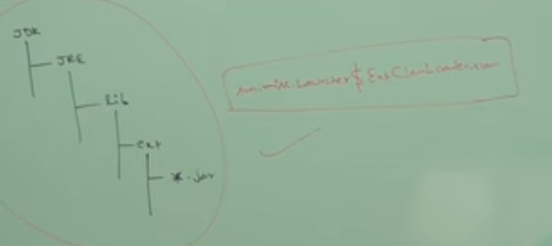

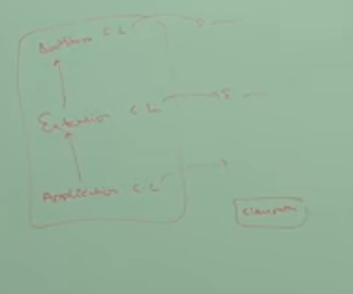

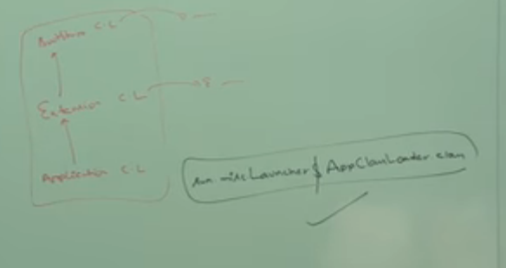

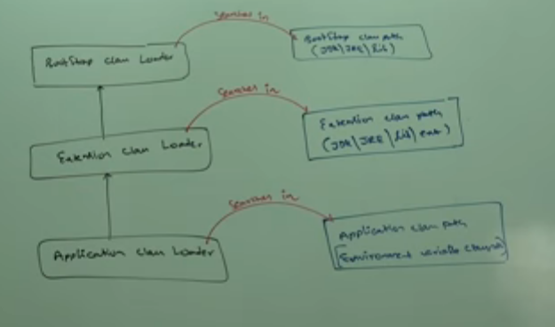

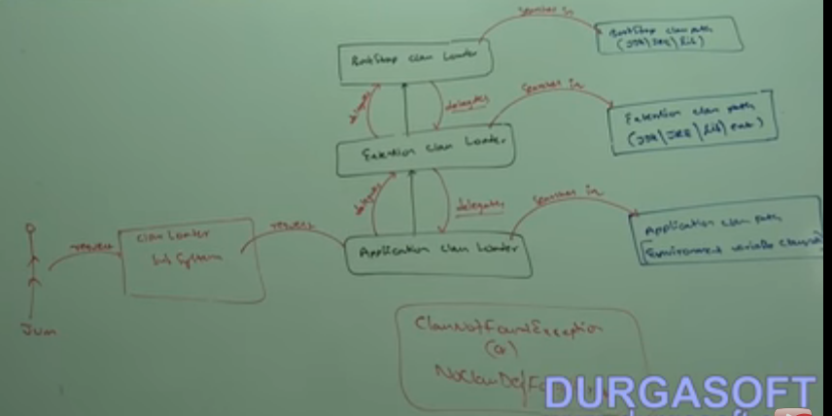

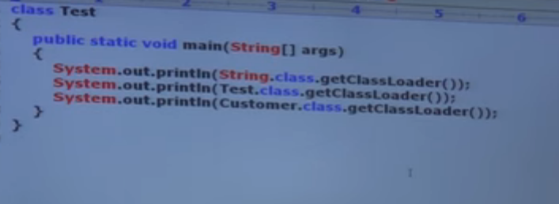

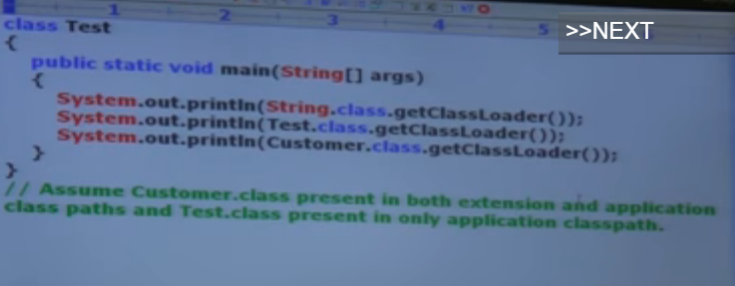

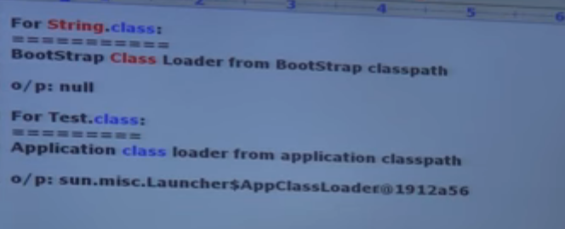

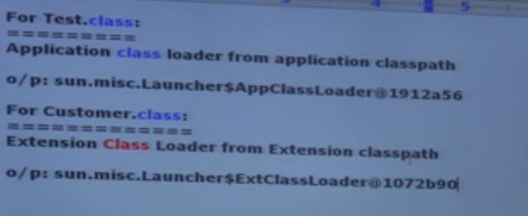

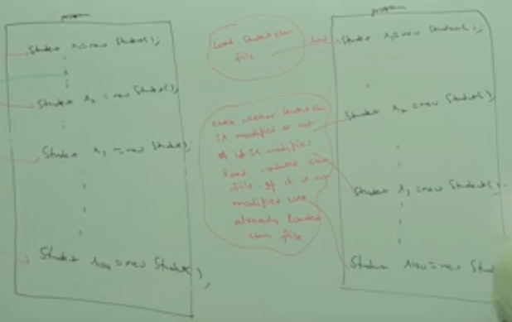

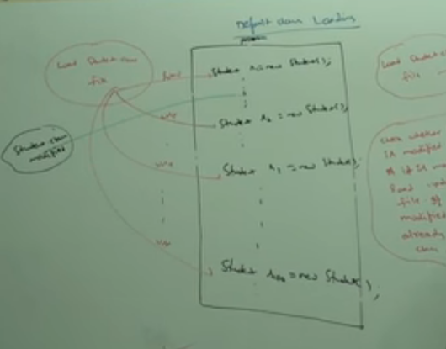

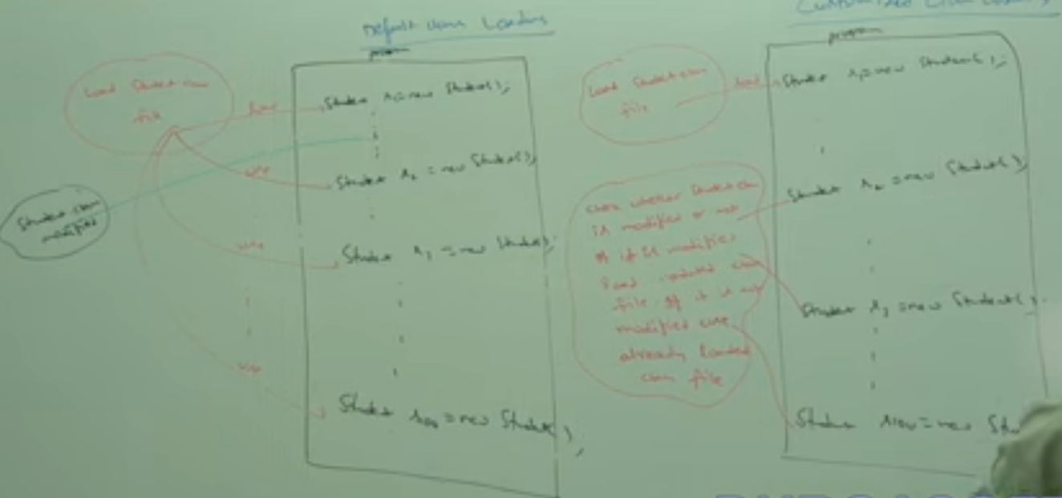

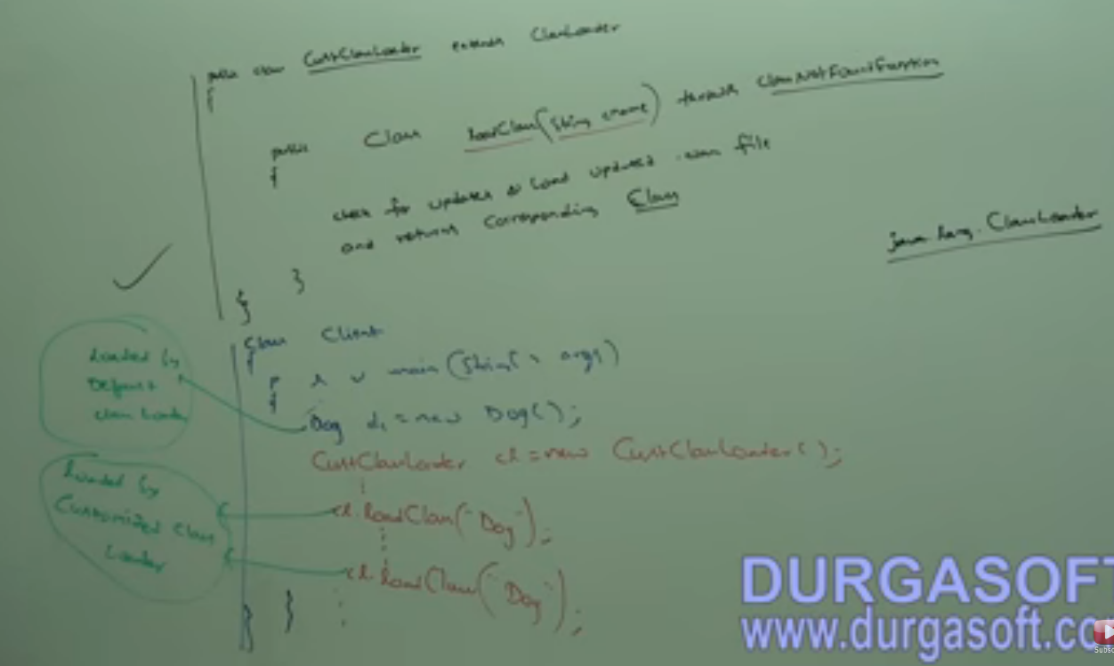

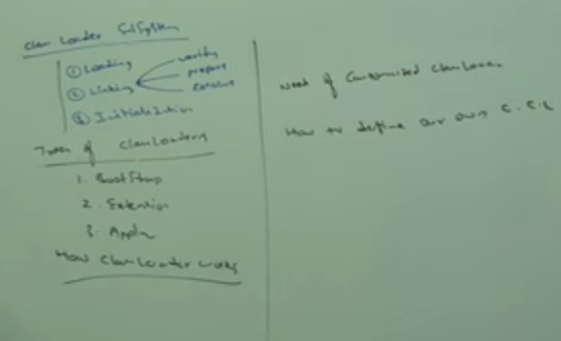

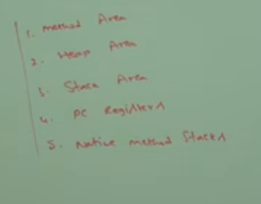

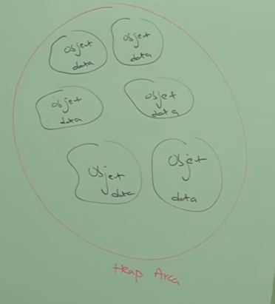

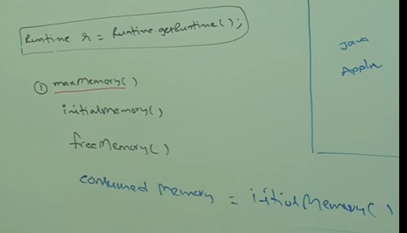

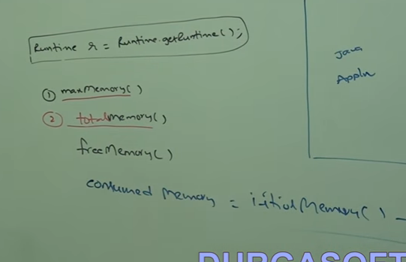

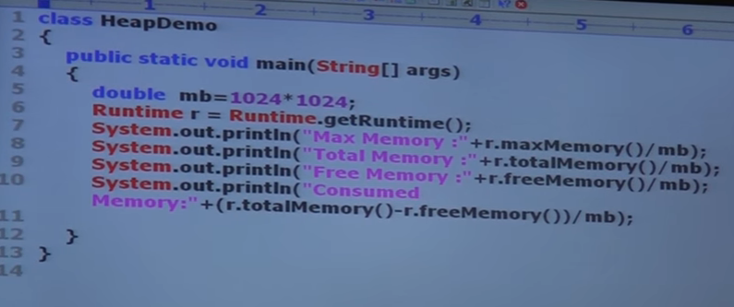 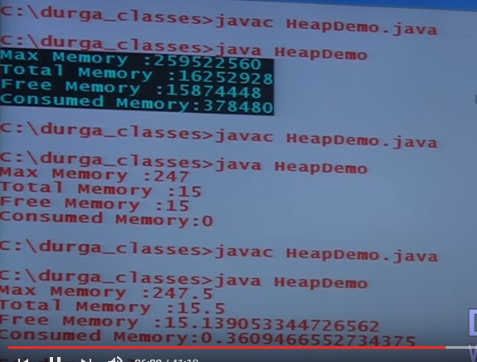

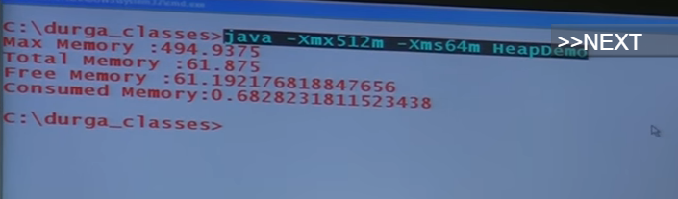

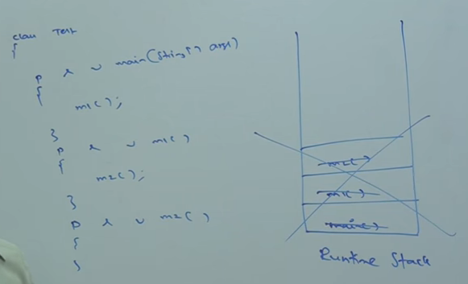

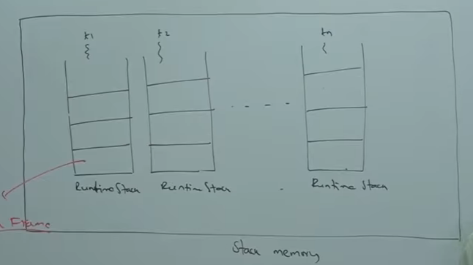

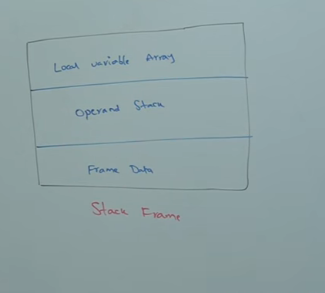

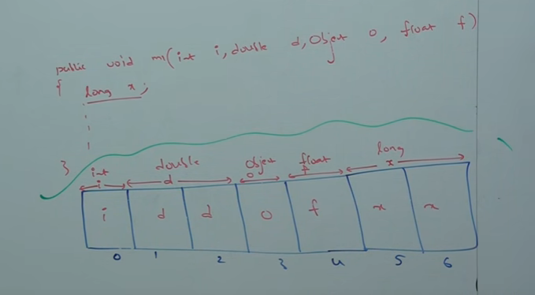

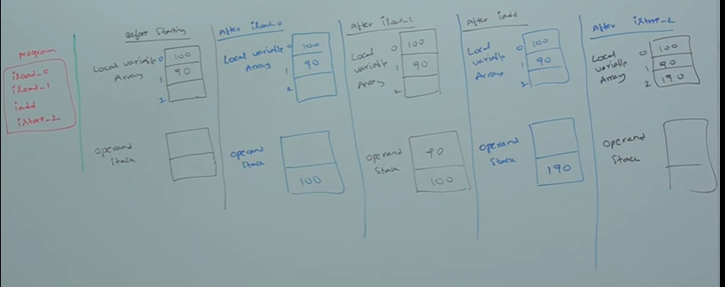

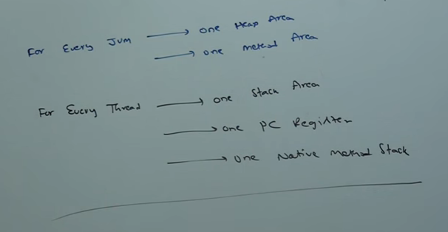

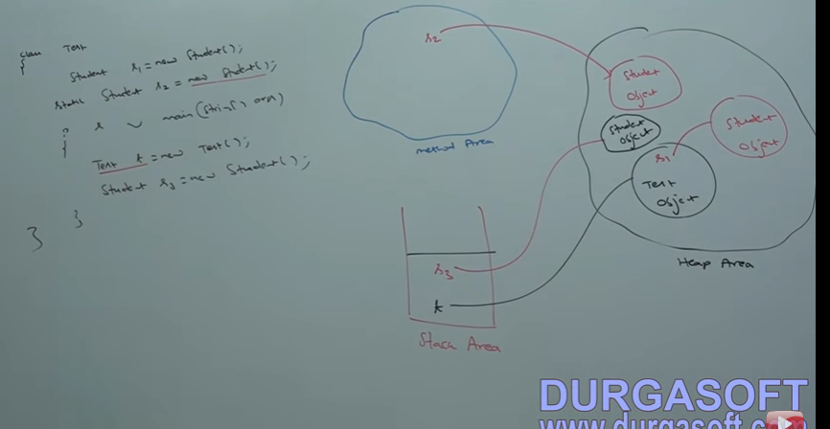

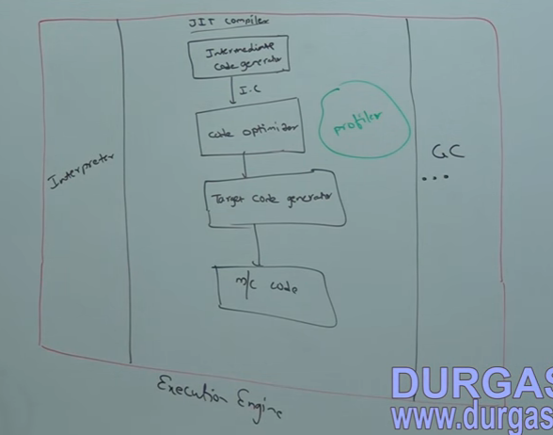

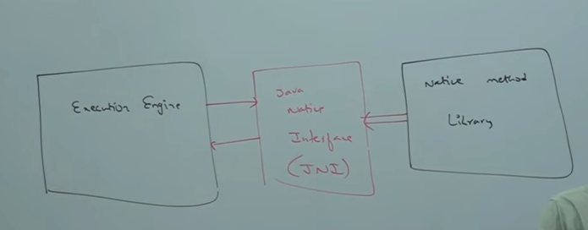

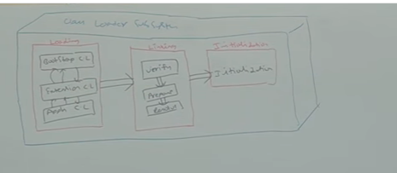

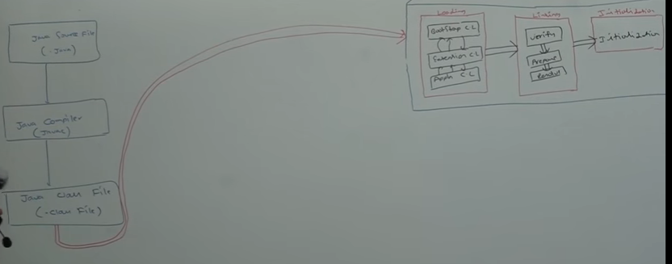

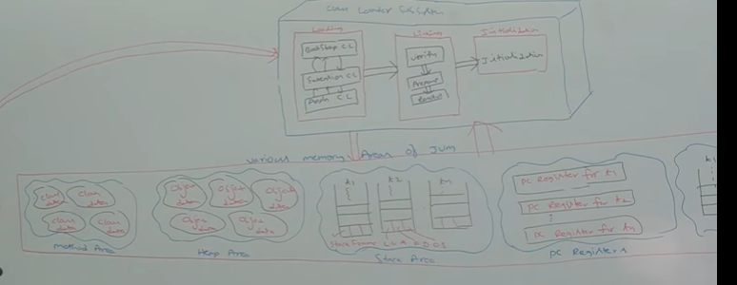

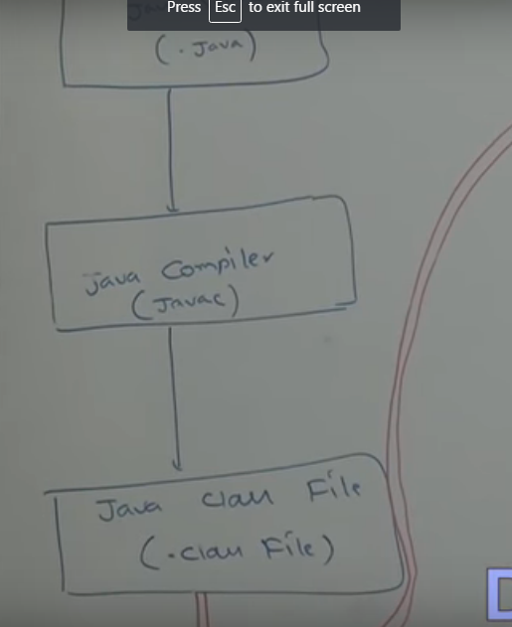

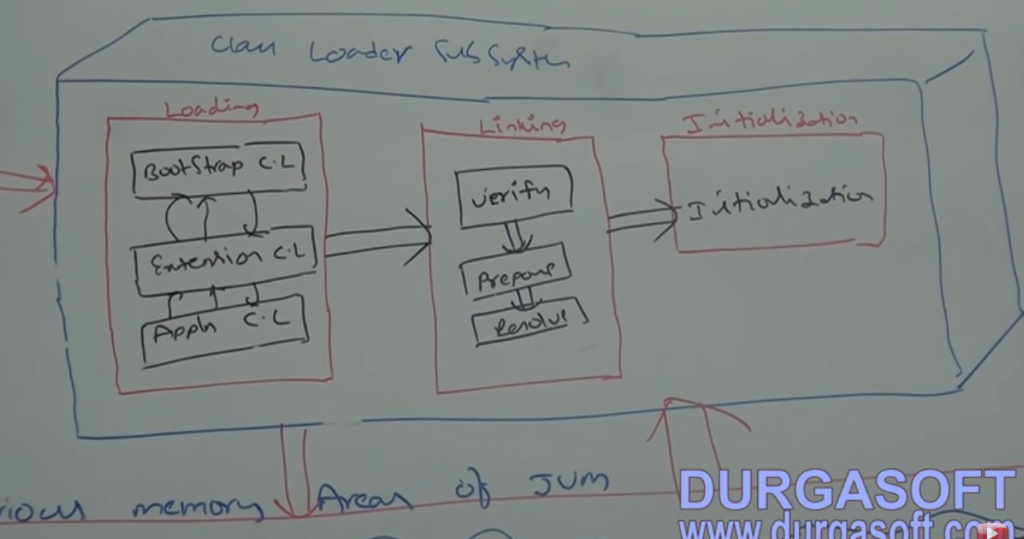

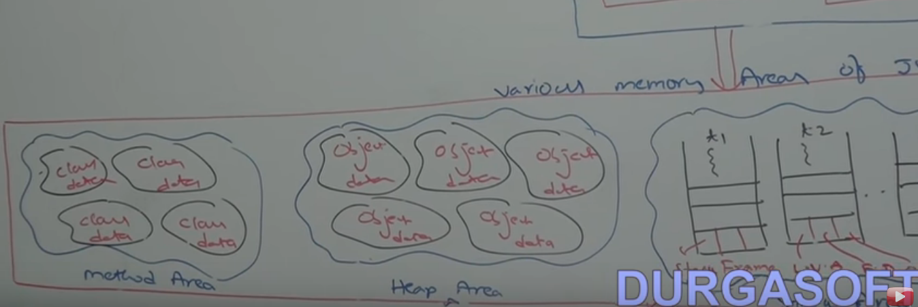

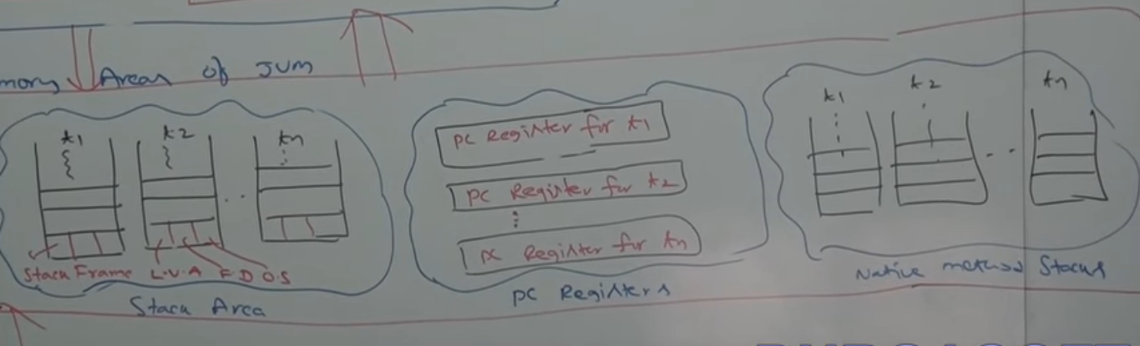

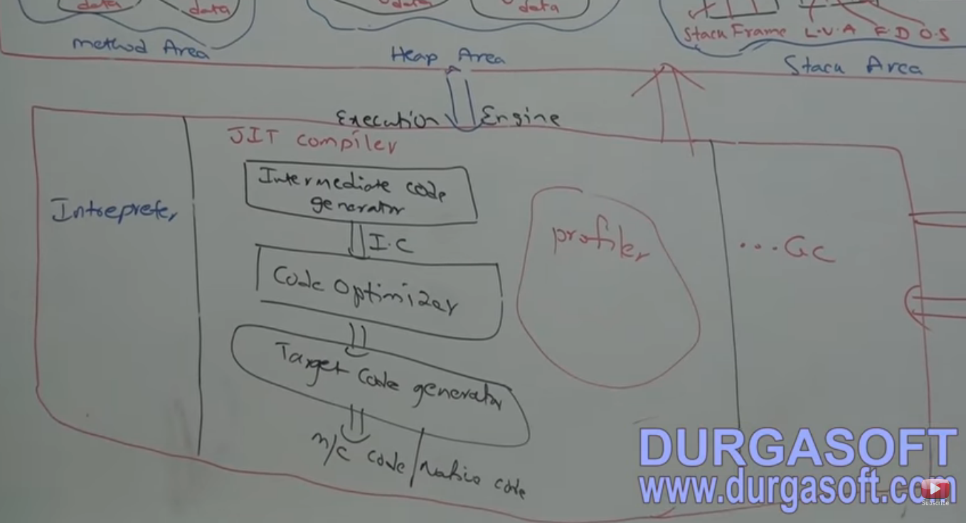

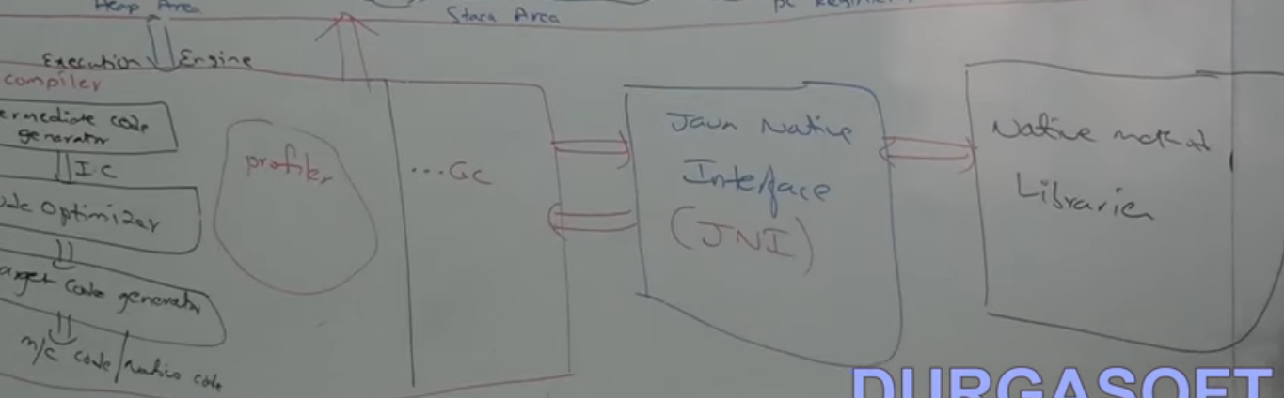

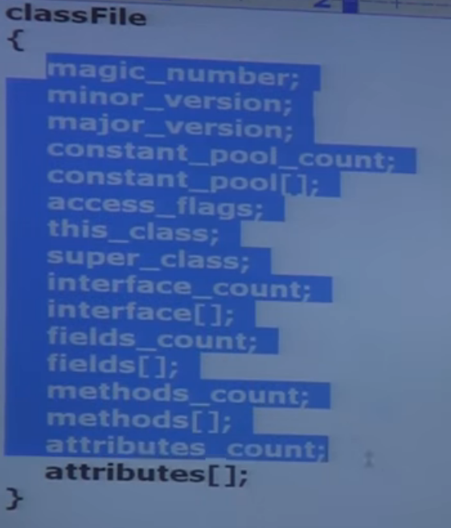

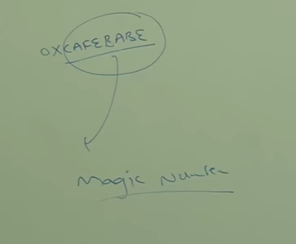

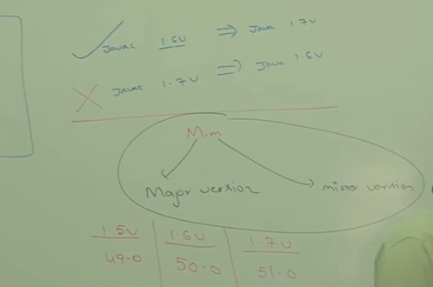

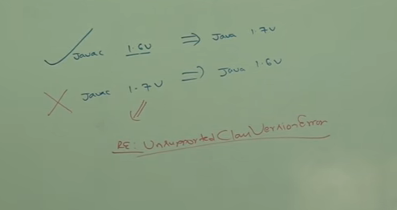

Method Area :- One per JVM. Not Thread Safe.

NeedNot be continuous memeory block in jvm. Contains all the classes data. Class loader loads each class into Method Area.

Heap Area :- One per JVM, created at the time of JVM startup. Object and corresponding instance variable is stored here.

Every Array in java is object and hence will be stored in heap area.

Can be accessed by multiple threads. And data stored in heap memory is not Thread Safe. Heap Area need not be continuous.

A java appl can communicate with jvm using Runtime Object.

Runtime Class present in java.lang pack and it is Singleton Class.

Runtime r = Runtime.getRuntime();

r.maxMemory();

r.TotalMemory(); // Initial Memeory

r.freeMemory();

How to set maximum and minimum heap size?

Max Heap Memory : -Xmx512m

Min Heap Memory ? -Xms64m

Stack Area :- For every thread, JVM will create a separte stack at the time of thread creation.

each and every method call performed by the thread in the stack including local variables.

After completing a method the corresponding entry from the stack will be removed. After completing all method call the empty stack will be destroyed JVM

just before terminating the thread.

The data in stack is available for the corresponding thread and not available to remaining thread and hence this area is thread safe.

stack frame : - local variable array, opreation stack, frame data

jvm uses operand stack as workspace. some instuctions can push values to Operan stack and can pop too. Some instuctions can perform required operations.

Frame Data contains all symbolic ref corresponding to that method. it also contains info about exceptions.

PC Registers:-

For every thread a separate will be create at the time of thread creation. It contains the address of current executing instuctions.

ONce instuctions execution completes , pc register will be incremented to hold address of next instuctions.

Native Method Stack :-

For every thread JVM will create a separte Native method stack. All native methods will be stored in the corresponding native method stack.

=====================================

conclusions: -

Method Area, Heap Area and Stack Area are Imp memory areas wrt programmer.

Method Area and Heap Area are Per JVM. Stack Area, PC register and Native method stack is for per Thread.

Static Variables will be stored in method area.

Instance Variabls will be stored in heap area.

Local Variables will be stored in stack area.

=====================================

Execution Engine:-

Central component of JVM. It is responsible to execute java Class Files.

Contains 1. Interpreter, 2. JIT compiler.

1. Interpreter:- it is responsible to read byte code and interpret into m/c code (native) line by line.

The pblm with interpreter is it interprets multiple times even same method invokes multiple times, which reduces performance.

To overcome this problem, Sun introduced JIT compiler in 1.1 v.

2. JIT Compiler :- The main purpose of jit compiler is to improve performance. Internally it maintains a separate count for every method call.

whenever JVM encouters any method, first the method will be interpreted normally by the interpreter and Jit compiler incremtns the count variable.

This proceess will be continued for every method. if any method call reaches threshold value then JIT compiler identifies that it is really repeated mthod

1.e., HOT SPOT> Immediately JIT compiler identifes that method and generates corresponding native code, so that JVM uses it directly hence performance

will be imporved.

Some advanced jit compiler generated native code if count value reaches threshold second time and hence most optimized sol is applied.

Internally profiler, which is the part of jit Compiler is responsible to identify HOT SPOTS.

NOTE:- 1. JVM interprets total program atleast once.

2. JIT compilation is applicable only for repeatedly required methods, not for every method.

=========================================

ClassFile Structure:-

In which way .class file saves

magic number :- 1st 4 bytes of classfile . predifined value used by jvm to identify .class file generated by valid compiler or not.

The value is 0xCAFEBABE.

iF jvm unbale to find valid magic number then we will runtime exception saying java.lang.classFormatError... incompatible magic value

Minor and Major version:-